***Muhammad Rahim***

***ST10043611***

***PROG6212***

***POE PART 1***

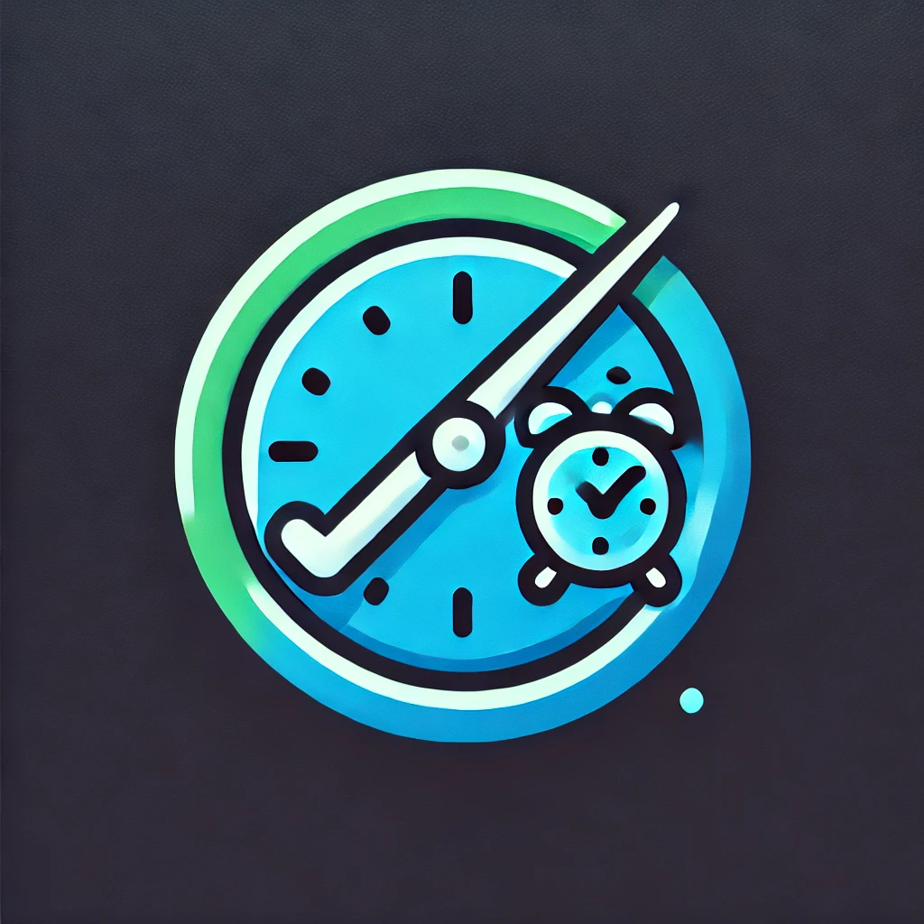

***Table Of Contents***

1. Documentation: 3

Design Decisions and Structure: 3

Database Design: 3

Assumptions and Constraints: 3

2. UML Class Diagram for Databases 4

3. Project Plan 5

These phases would have to be included in the project's plan of action: 5

Phase 1: Information Collecting (03/09/2024): 5

Phase 2: UML Design and Database Structure (04/09/2024): 5

Phase 3: GUI Sample (05/09/2024): 5

Phase 4: Evaluation and Improvement (07/09/2024): 5

Dependencies: 5

4. GUI IU: 6

Home Page Part 1 6

Home Page Part 2 6

Home Page Part 3 7

Submit Page Part 1 8

Submit Page Part 2 8

Approve Page Part 1 9

Approve Page Part 2 9

Approve Page Part 3 10

5. Version Control 11

GitHub Link 11

References 13

# Documentation:

Design Decisions and Structure:  
GUI Design: Included in the user interface (UI) is the following:  
Homepage: Contains business-related photos and an outline of the Contract Monthly Claim System (CMCS). This section will act as an overview and offer simple access to the program's various features.  
Claim Submission Form: IC educators can enter their hourly rate, the total amount of hours worked, and any supporting documentation they may have uploaded on the Claim Submission Form, which is a different page.  
Approval Dashboard: An additional page that academic managers and program coordinators utilize to examine, accept, or deny claims made by educators.  
To guarantee that customers can quickly find their way between the home page and the other essential features, the design will center on a simple, user-friendly layout.

Database Design: Important data elements such as contractor information, claim filings, supporting documentation, and approval statuses will be managed by the database. Effective connection management and data processing will be made easier with the help of relational databases such as Microsoft SQL Server Management.

Assumptions and Constraints:  
Everyone who uses it will have a simple entry to the system because it will be immediately available without requesting user authentication.  
The main page will include pertinent business photos along with a description of the capabilities and goals of the system.  
To facilitate user interactions, the claim filing and approval capabilities will be divided into independent places of interest.

# UML Class Diagram for Databases

(Please Zoom in to View Image Clearer)

# Project Plan

### These phases would have to be included in the project's plan of action:

Phase 1: Information Collecting (03/09/2024): Establish specifications for the approval dashboard, claim submission process, and home page.

Phase 2: UML Design and Database Structure (04/09/2024): To facilitate the claims and approval functionality, construct the UML class diagram and database schema.

Phase 3: GUI Sample (05/09/2024): Using MVC in.NET Core, construct the home page, claim submission form, and approval dashboard.

Phase 4: Evaluation and Improvement (07/09/2024): Examine the working model, get input, and make any necessary modifications to the design.

### Dependencies:

Before the database is incorporated with the claims and approvals GUI, the database schema must be defined.

To guarantee a consistent user experience, the construction of the claim submission and approval pages must align with the layout of the Home page.

# GUI IU:

Home Page Part 1 (Provides a brief overview of the website and what it strives to do). (Please Zoom in to see the image clearly).

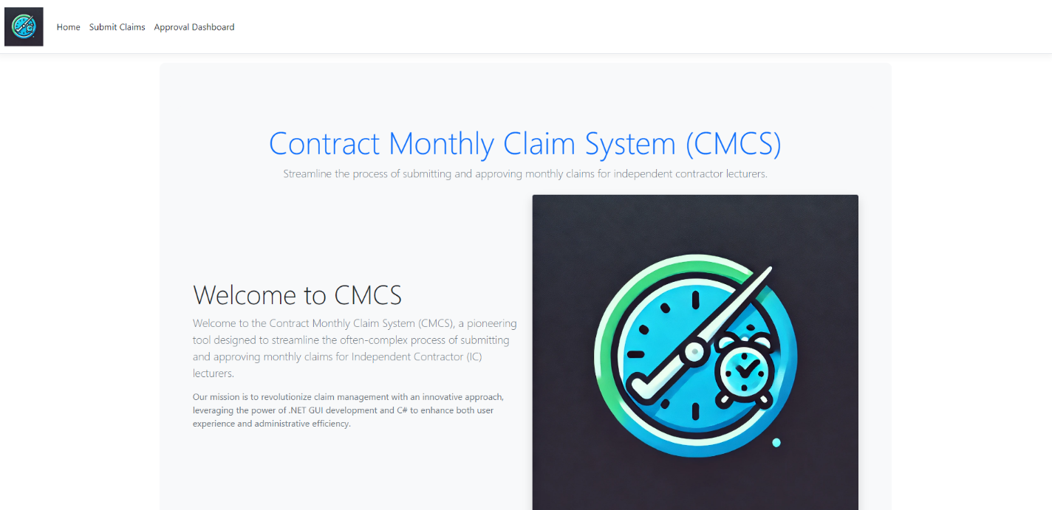

Home Page Part 2 (Provides the Main Key Features of the website). (Please Zoom in to see the image clear).



Home Page Part 3 (Provide a call-to-action button when clicked on, “Get Started” the submit claim view opens). (Please Zoom in to see the image clear).

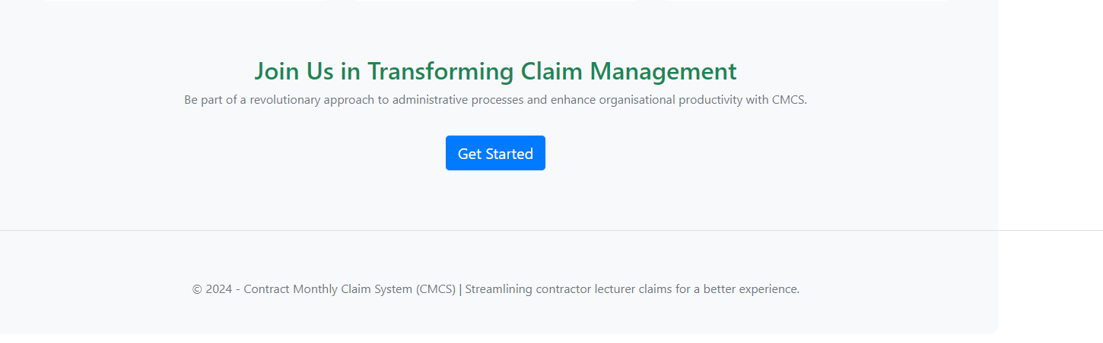

Submit Page Part 1 (Allows the user to enter the name, Hourly Rate in Rands, Total Hours worked and lastly allows documents to be uploaded). (Please Zoom in to see image clear).

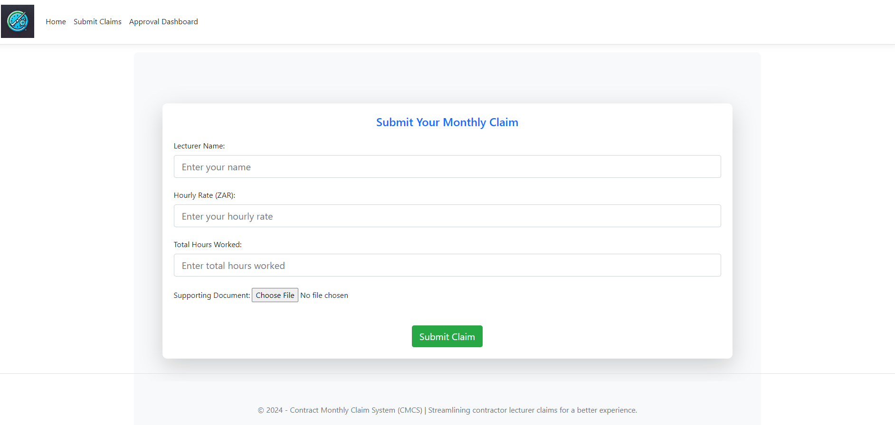

Submit Page Part 2 (Shows what it looks like when details are entered in the form and once you click on submit it just clears the form as no functionality is needed in this part of POE). (Please Zoom in to see image clear).

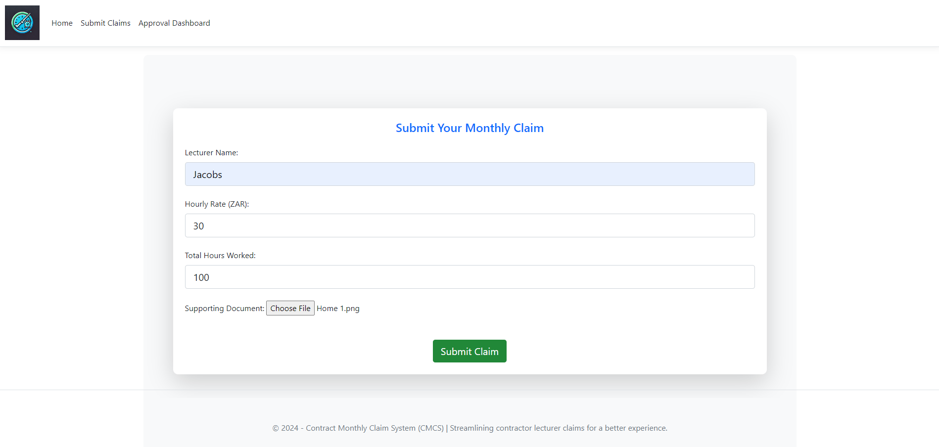

Approve Page Part 1 (Provides an overview of how it might look after the lecture submits a claim will show the Lectures Name, Hourly Rate, Hours Worked, Total Amount as well shows the status of it between Submitted which means pending then approved and rejected is the other two status options). (Please Zoom in to see the image clearly).

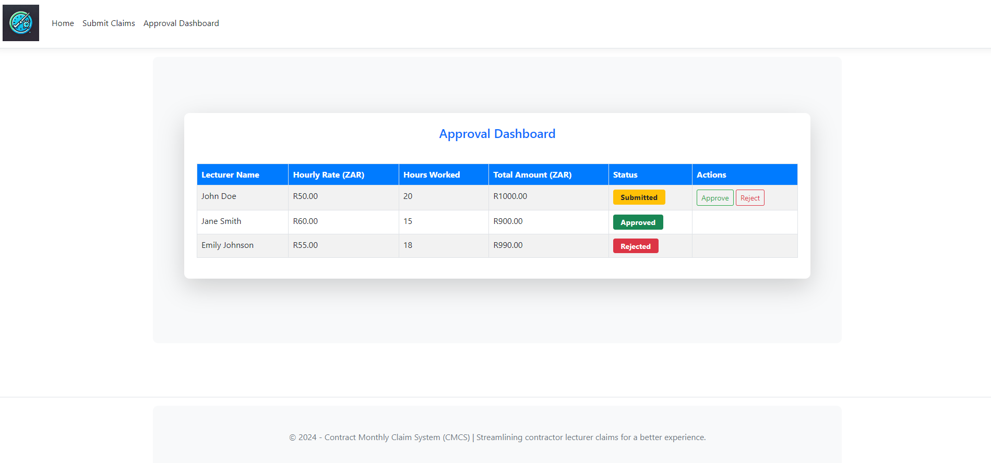

Approve Page Part 2 (Provides an action button which allows the user to Approve the claim when hovering over the Approve button it will go green, so the user is aware that they are clicking the right one, no functionality is needed in this part of POE). (Please Zoom in to see image clear).

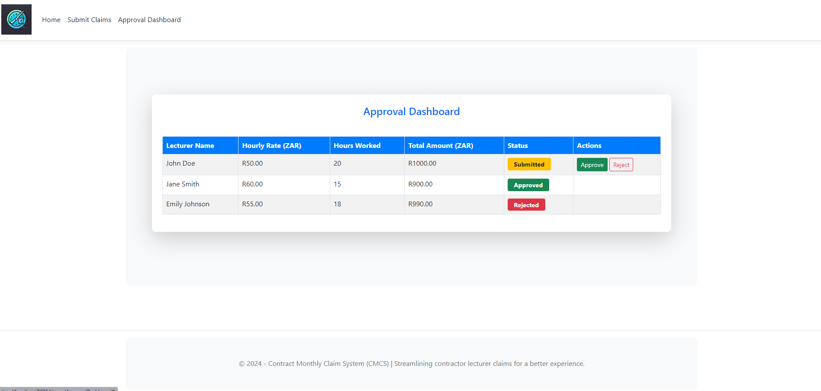

Approve Page Part 3 (Provides an action button which allows the user to Reject the claim when hovering over the Reject button it will go Red, so the user is aware that they are clicking the right one, no functionality is needed in this part of POE). (Please Zoom in to see the image clearly).

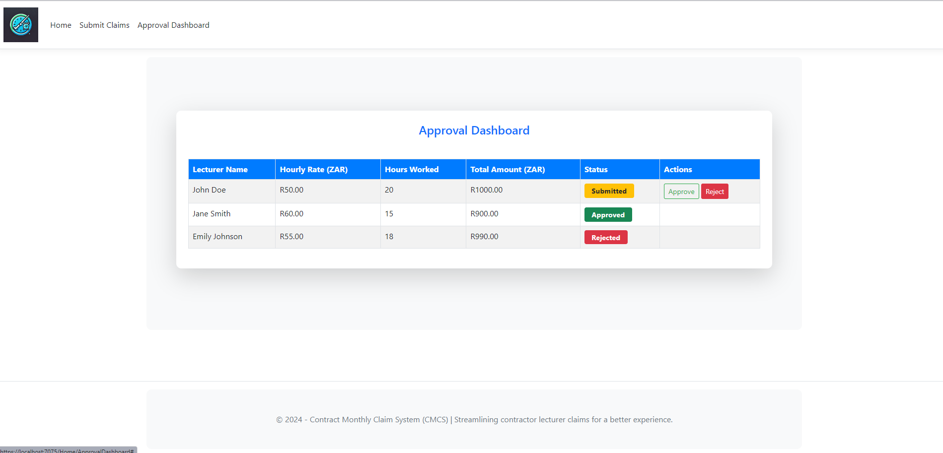

# Version Control

GitHub Link (Use the branch that says Completed-Code-with-comments as that is my final Code Or use the Link I provide below ): <https://github.com/MuhammadRahimST10043611/Muhammad-Rahim_ST10043611_Prog6212-Poe1/tree/Completed-Code-with-comments>

All the branches that I have created stem from the master branch. My final branch is Completed-Code-with-comments that is the branch that contains my final code for POE PART 1. (Please Zoom in to see the image clearly).

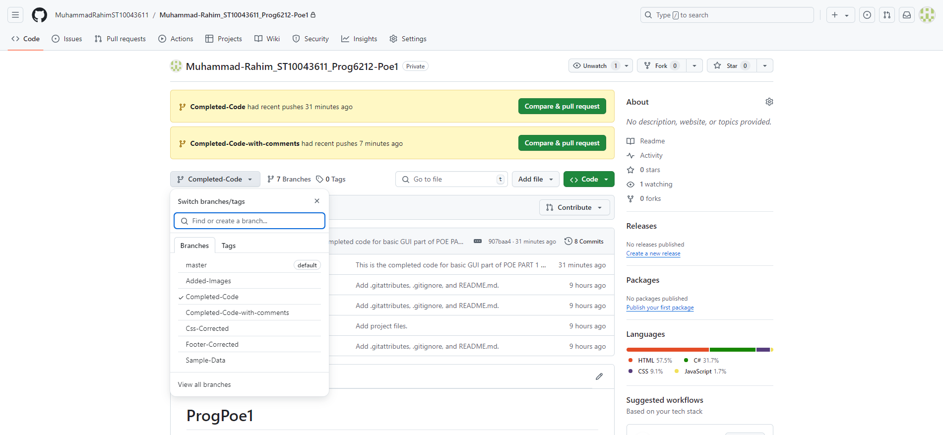

Please find below my, regularly commit and push changes to the GitHub repository (5 Times) with clear and descriptive commit messages. (Please Zoom in to see the image clearly).

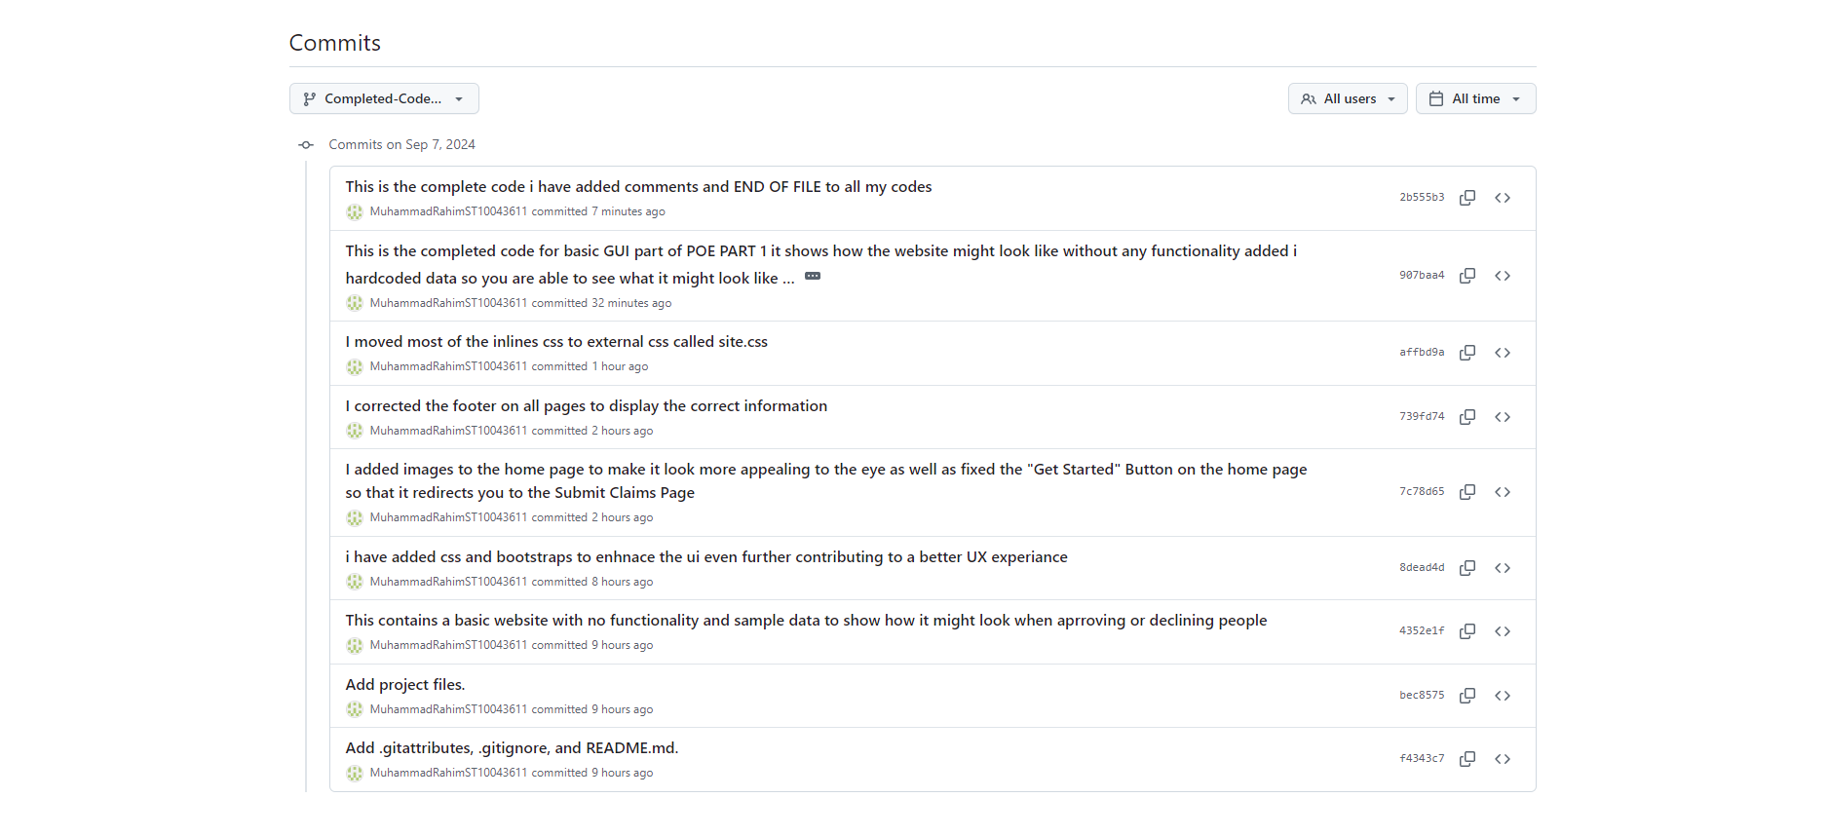

Please find below my Program.cs which is my start up program that shows my Name, Student Number and Group that I am in as well as my References that I used for my code. However, I did include references in this document down below as well. (Please Zoom in to see the image clearly).

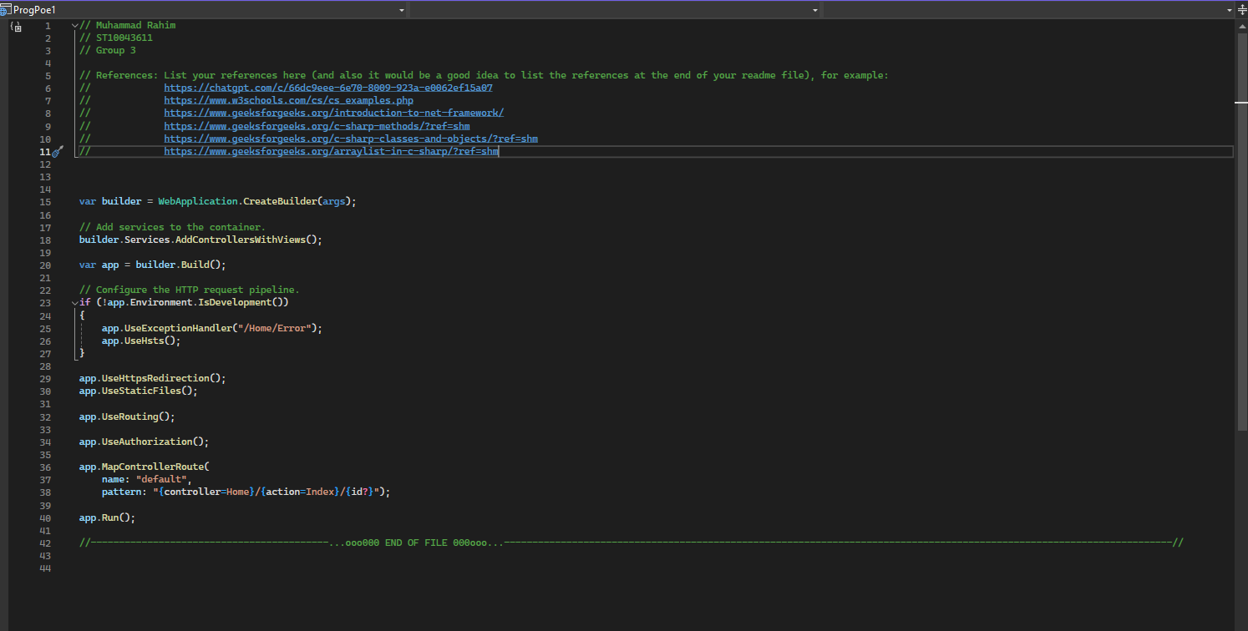

(W3Schools, n.d.) (GeeksForGeeks, 2022) (ChatGBT, 2024) (GeeksForGeeks, 2024) (GeeksForGeeks, 2021) (GeeksForGeeks, 2022) (Kim, 2024) (Kim, 2024) (Kim, 2024) (Kim, 2024) (Kim, 2024) (Kim, 2024) (Kim, 2024)

# References

ChatGBT, 2024. *Code Documentation and Overview of Code with Comments.* [Online]   
Available at: https://chatgpt.com/c/66dc9eee-6e70-8009-923a-e0062ef15a07  
[Accessed 7 September 2024].

GeeksForGeeks, 2021. *C# | Methods.* [Online]   
Available at: https://www.geeksforgeeks.org/c-sharp-methods/?ref=shm  
[Accessed 7 September 2024].

GeeksForGeeks, 2022. *ArrayList in C#.* [Online]   
Available at: https://www.geeksforgeeks.org/arraylist-in-c-sharp/?ref=shm  
[Accessed 7 September 2024].

GeeksForGeeks, 2022. *ArrayList in C#.* [Online]   
Available at: https://www.geeksforgeeks.org/arraylist-in-c-sharp/?ref=shm  
[Accessed 7 September 2024].

GeeksForGeeks, 2024. *Introduction to .NET Framework.* [Online]   
Available at: https://www.geeksforgeeks.org/introduction-to-net-framework/  
[Accessed 7 September 2024].

Kim, Y.-S., 2024. *LU1_Theme1_Operator_Overloading,* Cape Town: Youn-Soo Kim.

Kim, Y.-S., 2024. *LU1_Theme2_Object_Lifetime,* Yoon-Soo Kim: Cape Town.

Kim, Y.-S., 2024. *Theme 1: Advanced C# Features,* Cape Town: Youn-Soo Kim.

Kim, Y.-S., 2024. *Theme 1: Building and Configuring Class Libraries,* Cape Town: Youn-Soo Kim.

Kim, Y.-S., 2024. *Theme 3: Dynamic Types and the Dynamic,* Cape Town: Youn-Soo Kim.

Kim, Y.-S., 2024. *Theme 3: Language Integrated Queries,* Cape Town: Youn-Soo Kim.

Kim, Y.-S., 2024. *Youn-Soo Kim,* Cape Town: Youn-Soo Kim.

W3Schools, n.d. *C# Examples.* [Online]   
Available at: https://www.w3schools.com/cs/cs_examples.php  
[Accessed 7 September 2024].